1. Simple Calculator Agent—II

Refer [this video](https://www.youtube.com/watch?v=y9m3i12qkms)

Create first user, password and database. We will name all three as ‘ashok’.

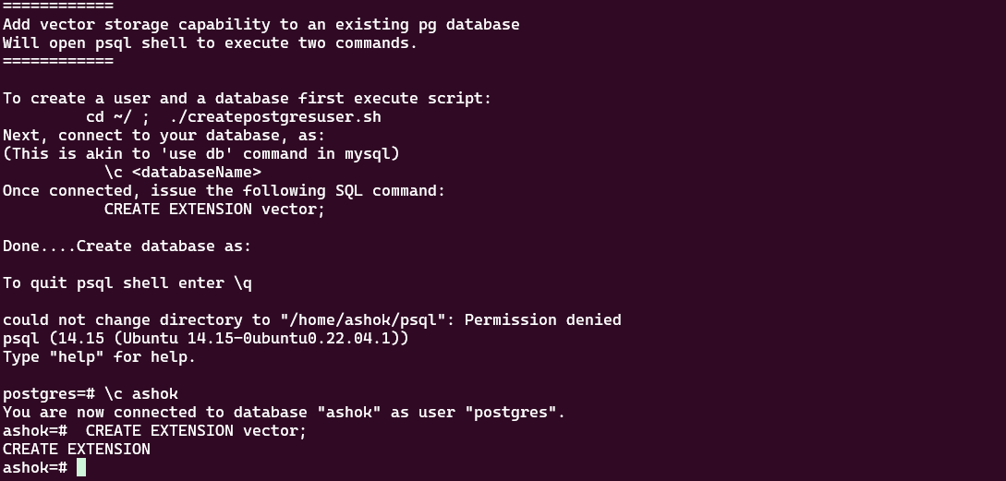

Figure : Create user, password and database. NAme all the three as ashok. Note that user is called ROLE in postgres.

Figure : Make database 'ashok' capable of being a vector database.

Result:



Figure : The bottom chat window. **The middle rectangle** displays step-by-step messages.

************